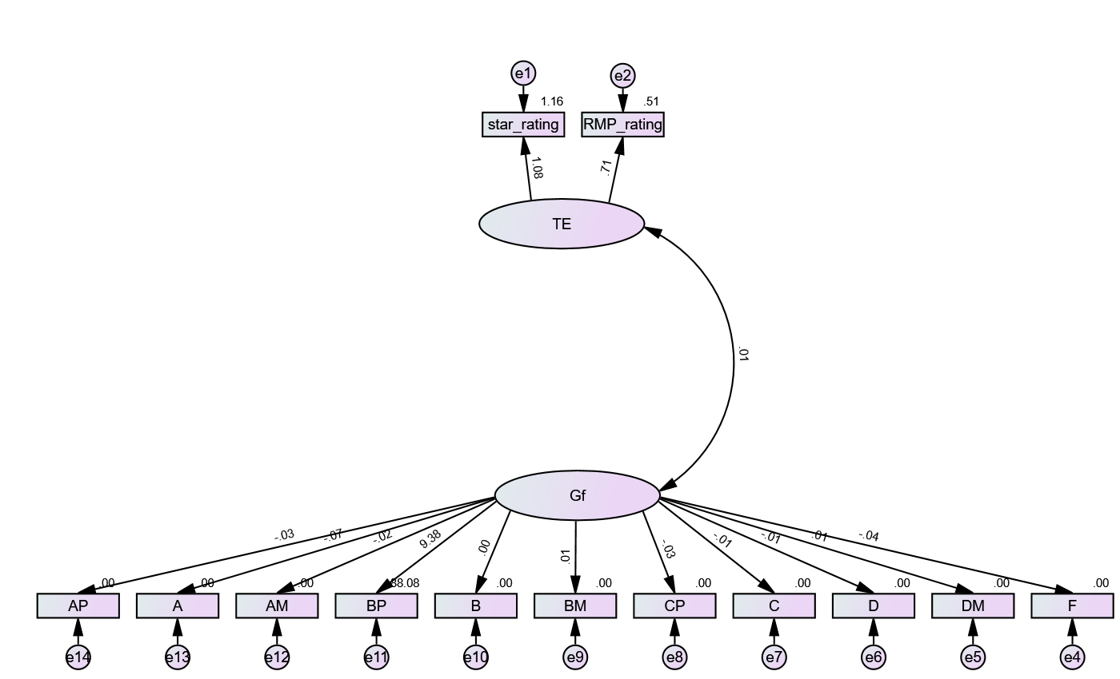

**Validity Analysis**

|  | **CR** | **AVE** | **MSV** | **MaxR(H)** | **TE** | **Gf** |
| --- | --- | --- | --- | --- | --- | --- |
| **TE** | 0.907 | 0.836 | 0.000 | 1.195 | **0.914** |  |
| **Gf** | 11.367 | 8.008 | 0.000 | 375.435 | 0.014 | **2.830** |

**Validity Concerns**

No validity concerns here.  
  
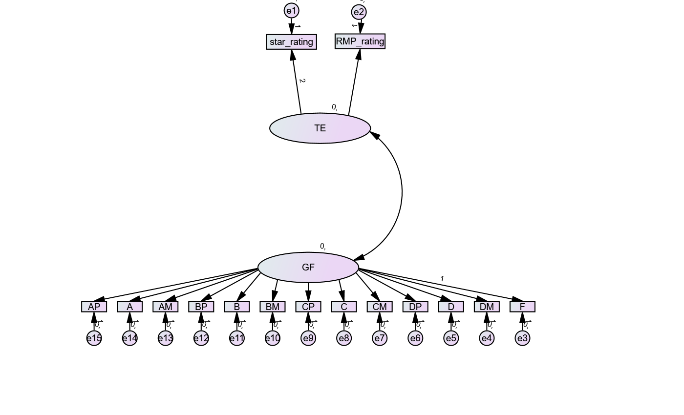

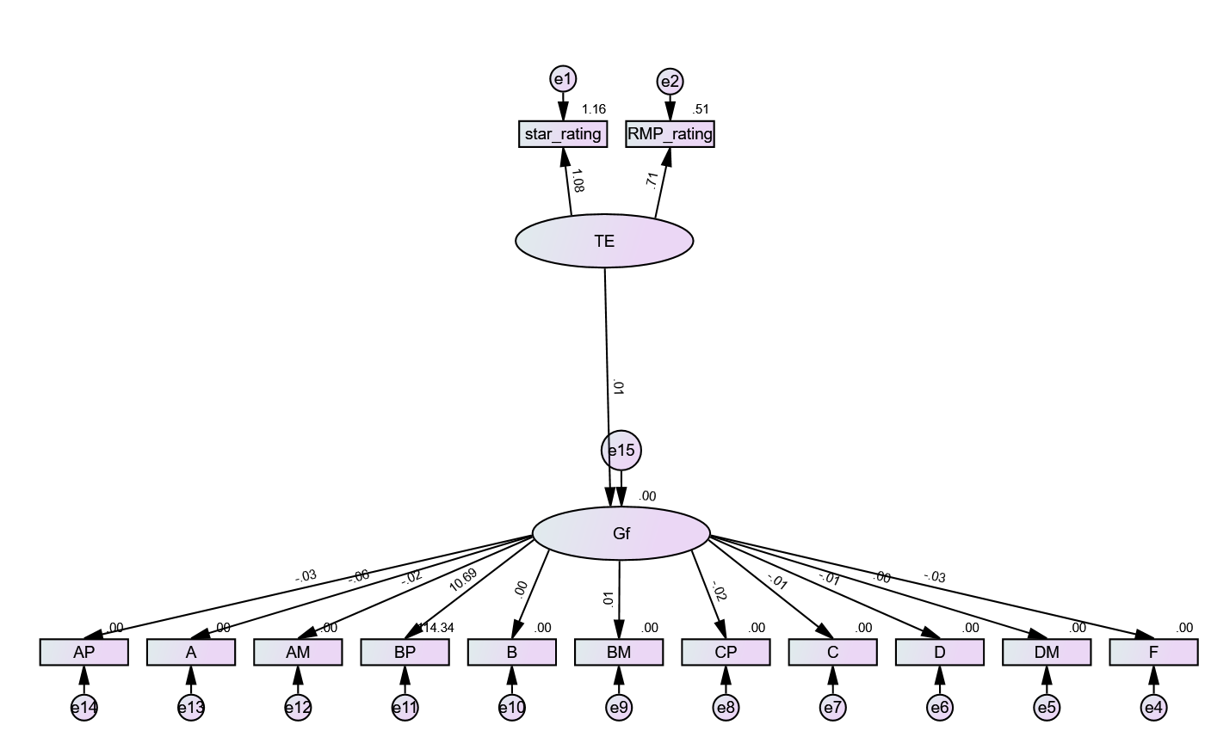  
  
  
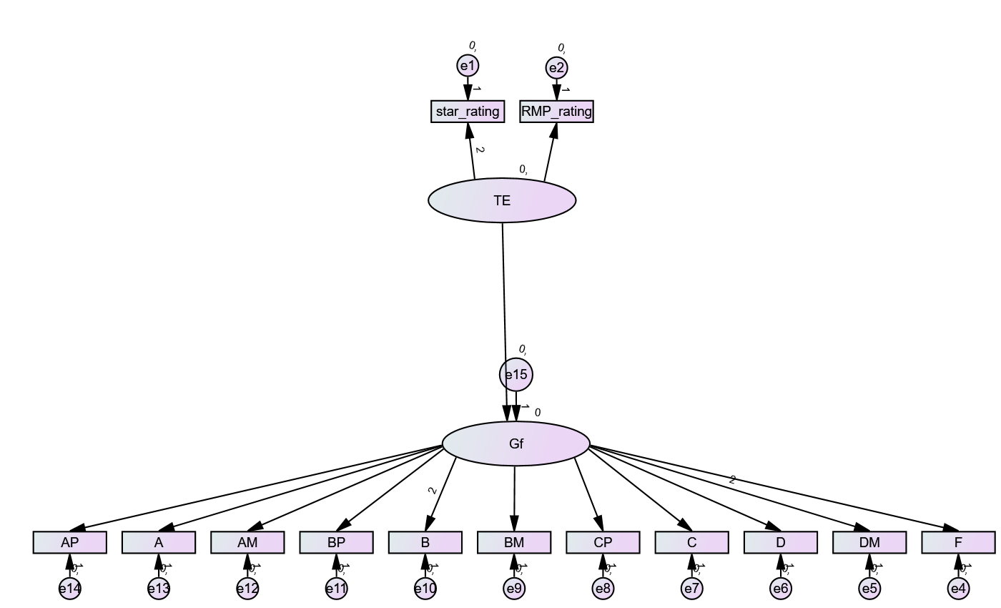

| **Measure** | **Estimate** | **Threshold** | **Interpretation** |
| --- | --- | --- | --- |
| CMIN | 145.495 | -- | -- |
| DF | 65.000 | -- | -- |
| CMIN/DF | 2.238 | Between 1 and 3 | Excellent |
| CFI | 0.357 | >0.95 | Terrible |
| RMSEA | 0.214 | <0.06 | Terrible |
| PClose | 0.000 | >0.05 | Not Estimated |

| **Measure** | **Terrible** | **Acceptable** | **Excellent** |
| --- | --- | --- | --- |
| CMIN/DF | > 5 | > 3 | > 1 |
| CFI | <0.90 | <0.95 | >0.95 |
| RMSEA | >0.08 | >0.06 | <0.06 |
| PClose | <0.01 | <0.05 | >0.05 |

*Note: Hu and Bentler (1999, "Cutoff Criteria for Fit

| **KMO and Bartlett's Test** | | |
| --- | --- | --- |
| Kaiser-Meyer-Olkin Measure of Sampling Adequacy. | | .123 |
| Bartlett's Test of Sphericity | Approx. Chi-Square | 164.267 |
| df | 78 |
| Sig. | .000 |

| **Descriptive Statistics** | | | |
| --- | --- | --- | --- |
|  | Mean | Std. Deviation | Analysis N |
| star_rating | 3.764 | .7263 | 28 |
| RMP_rating | 3.689 | 1.0549 | 28 |
| AP | .71 | 1.013 | 28 |
| A | 1.71 | 1.243 | 28 |
| AM | .39 | .629 | 28 |
| BP | .57 | .690 | 28 |
| B | .79 | .833 | 28 |
| BM | .21 | .499 | 28 |
| CP | .21 | .418 | 28 |
| C | .18 | .476 | 28 |
| D | .04 | .189 | 28 |
| DM | .04 | .189 | 28 |
| F | .21 | .787 | 28 |
| CM | .00 | .000 | 28 |
| DP | .00 | .000 | 28 |

| **Reliability Statistics** | |
| --- | --- |
| Cronbach's Alphaa | N of Items |
| -41.067 | 11 |
| a. The value is negative due to a negative average covariance among items. This violates reliability model assumptions. You may want to check item codings. | |